1. Dataset plot
In this problem, we use the fetch_20newsgroups dataset from sklearn package to plot the number of training documents per class.
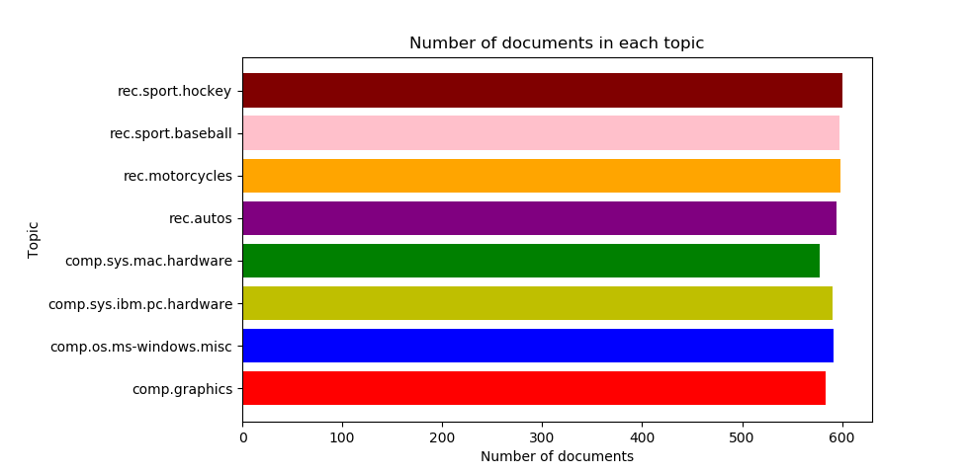
From the figure above, we could see that the data set is already balanced and in every class the number of documents is almost equivalent.

2. Create TF*IDF vector representation

A popular numerical statistic to capture the importance of a word is TFxIDF metric. This measure takes into account the words in the document. The discriminating words will most likely be those that are specialized terms describing different types of accessories and hence will occur in fewer documents.
In this problem, we need to convert the documents of 8 classes into numerical feature vectors. Firstly, we use ‘snowball’ to remove morphological affixes from words. After that, we remove all punctuation, all symbols and non-ascii characters. We used TfidfTransformer to calculate TFIDF, where tf(t, d) represents the frequency of term t in document d, and inverse document frequency is defined as: idf(t) = log [ n / df(t)] + 1 and df(t) is the document frequency; the document frequency is the number of documents that contain the term t.

Token shape: (4732, 21795) [min_df = 2, enable_stopword = True, enable_stem = True]
TFxIDF shape: (4732, 21795) [min_df = 2, enable_stopword = True, enable_stem = True]
[min_df = 2] Number of terms: 21795
Token shape: (4732, 8818) [min_df = 5, enable_stopword = True, enable_stem = True]
TFxIDF shape: (4732, 8818) [min_df = 5, enable_stopword = True, enable_stem = True]
[min_df = 5] Number of terms: 8818

3. Calculate the TF*ICF
In order to quantify how significant a word is to a class, we calculate TFxICF. It is the same as TFxIDF, except that a class sits in place of a document; that is for a term t and a class c. And we need to find the 10 most significant terms in each of the 4 classes with respect to TFICF measure.

comp.sys.ibm.pc.hardware [u'scsi', u'drive', u'edu', u'ide', u'line', u'use', u'com', u'subject', u'organization', u'controller']

comp.sys.mac.hardware [u'edu', u'line', u'mac', u'subject', u'organization', u'apple', u'use', u'quadra', u'scsi', u'problem']

misc.forsale [u'edu', u'line', u'sale', u'subject', u'organization', u'new', u'post', u'com', u'university', u'offer']

soc.religion.christian [u'god', u'edu', u'christian', u'jesus', u'say', u'church', u'subject', u'people', u'line', u'know']

4. Reduce dimension
In this problem, we need to transform the data’s dimensional into a lower dimensional space. We use Latent Semantic Indexing (LSI) and NMF to lower the space into 50. As to LSI, we used the SVD decomposition to obtain left and right singular vectors and then get a lower space.

Token shape: (4732, 24849) [min_df = 2, enable_stopword = True, enable_stem = True]

TFxIDF shape: (4732, 24849) [min_df = 2, enable_stopword = True, enable_stem = True]

Shape of feature vec after LSI: (4732, 50)

Shape of feature vec after NMF: (4732, 50)

5. SVM
In next parts, we need to classify the documents into two categories ‘‘Computer Technology’ vs ‘Recreational Activity’. We need to combine documents of sub-classes of each class to form the set of documents for each class. And we need to assess the model by precision, recall and ROC curve.
In this part, based on LSI and NMF, we used SVM to make classification.

The goal is to figure out: whether it is worth keeping so many "rare" terms?

When min_df = 2
1) Hard- SVM with LSI
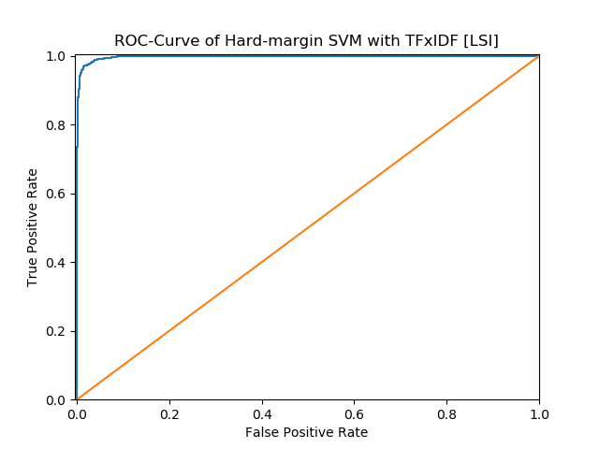

 | Precision | Recall | Accuracy
Computer technology | 0.9938 | 0.9295 | 0.9622
Recreational activity | 0.9349 | 0.9943 | 0.9622
Average | 0.9619 | 0.9644 | 0.9622

 | TP | FP | FN | TN
Computer technology | 1450 | 9 | 110 | 1581
Recreational activity | 1581 | 110 | 9 | 1450

We set computer technology as positive and recreational activity as negative to construct the confusion matrix as follow:

 | Ground Truth | Ground False
Predicted positive | 1450 | 9
Predicted negative | 110 | 1581

2) Hard- SVM with NMF
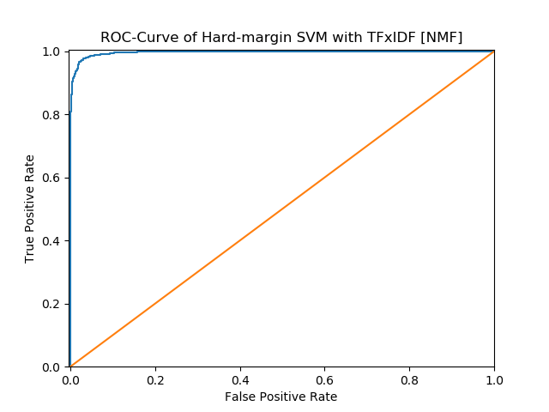

 | Precision | Recall | Accuracy
Computer technology | 0.9916 | 0.9090 | 0.9511
Recreational activity | 0.9174 | 0.9925 | 0.9511
Average | 0.9507 | 0.9545 | 0.9511

 | TP | FP | FN | TN
Computer technology | 1418 | 12 | 142 | 1578
Recreational activity | 1578 | 142 | 12 | 1418

We set computer technology as positive and recreational activity as negative to construct the confusion matrix as follow:
 | Ground Truth | Ground False
Predicted positive | 1418 | 12
Predicted negative | 142 | 1578

3) Soft- SVM with LSI
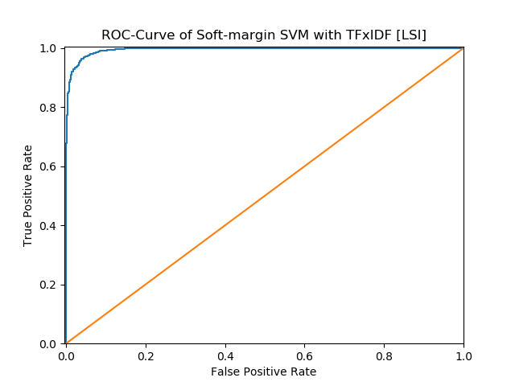

 | Precision | Recall | Accuracy
Computer technology | 0.9922 | 0.8917 | 0.9429
Recreational activity | 0.9033 | 0.9931 | 0.9429
Average | 0.9424 | 0.9477 | 0.9429

 | TP | FP | FN | TN
Computer technology | 1391 | 11 | 169 | 1579
Recreational activity | 1579 | 169 | 11 | 1391
We set computer technology as positive and recreational activity as negative to construct the confusion matrix as follow:

 | Ground Truth | Ground False
Predicted positive | 1391 | 11
Predicted negative | 169 | 1579
4) Soft- SVM with NMF
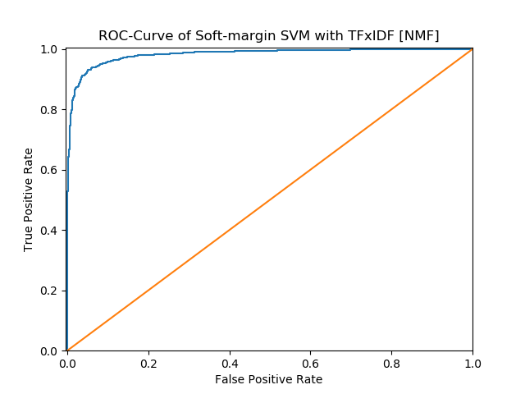

 | Precision | Recall | Accuracy
Computer technology | 1.0000 | 0.0410 | 0.5251
Recreational activity | 0.5152 | 1.0000 | 0.5251
Average | 0.5205 | 0.7576 | 0.5251

 | TP | FP | FN | TN
Computer technology | 64 | 0 | 1496 | 1590
Recreational activity | 1590 | 1496 | 0 | 64
We set computer technology as positive and recreational activity as negative to construct the confusion matrix as follow:
 | Ground Truth | Ground False
Predicted positive | 64 | 0
Predicted negative | 1496 | 1590
When min_df=5
- Hard-SVM with LSI
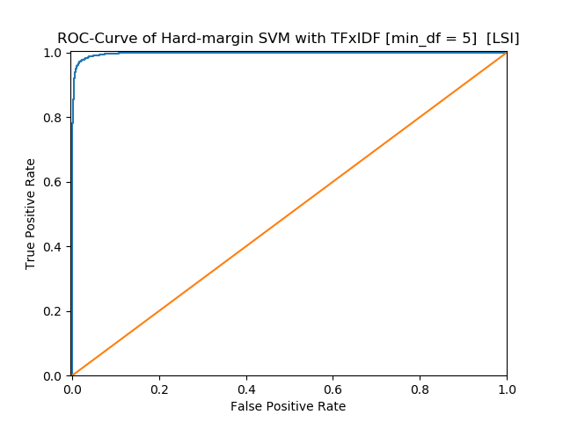

 | Precision | Recall | Accuracy
Computer technology | 0.9666 | 0.9827 | 0.9746
Recreational activity | 0.9827 | 0.9667 | 0.9746
Average | 0.9747 | 0.9747 | 0.9746

 | TP | FP | FN | TN
Computer technology | 1533 | 53 | 27 | 1537
Recreational activity | 1537 | 27 | 53 | 1533
We set computer technology as positive and recreational activity as negative to construct the confusion matrix as follow:
 | Ground Truth | Ground False
Predicted positive | 1533 | 53
Predicted negative | 27 | 1537

- Hard-SVM with NMF
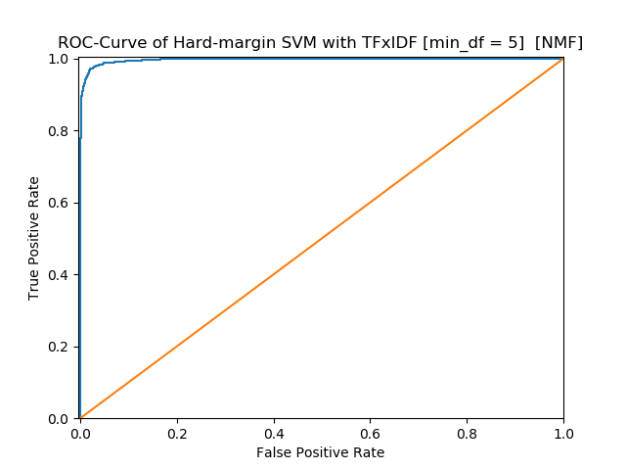

 | Precision | Recall | Accuracy
Computer technology | 0.9910 | 0.9173 | 0.9549
Recreational activity | 0.9244 | 0.9918 | 0.9549
Average | 0.9546 | 0.9577 | 0.9549

 | TP | FP | FN | TN
Computer technology | 1431 | 13 | 129 | 1577
Recreational activity | 1577 | 129 | 13 | 1431
We set computer technology as positive and recreational activity as negative to construct the confusion matrix as follow:
 | Ground Truth | Ground False
Predicted positive | 1431 | 13
Predicted negative | 129 | 1577

- Soft-SVM with LSI
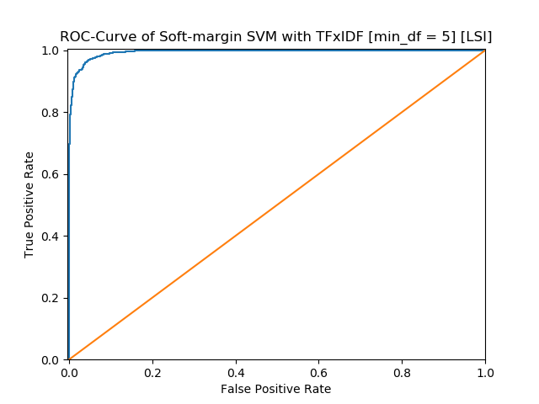

 | Precision | Recall | Accuracy
Computer technology | 0.9908 | 0.8981 | 0.9454
Recreational activity | 0.9084 | 0.9918 | 0.9454
Average | 0.9450 | 0.9496 | 0.9454

 | TP | FP | FN | TN
Computer technology | 1401 | 13 | 159 | 1577
Recreational activity | 1577 | 159 | 13 | 1401
We set computer technology as positive and recreational activity as negative to construct the confusion matrix as follow:
 | Ground Truth | Ground False
Predicted positive | 1401 | 13
Predicted negative | 159 | 1577
- Soft-SVM with NMF
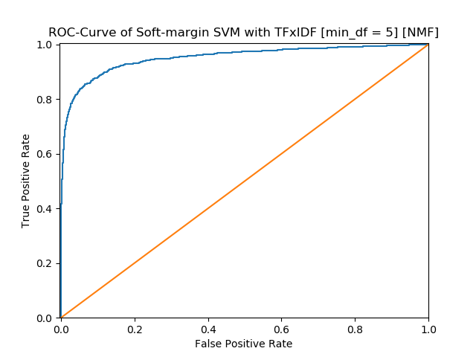

 | Precision | Recall | Accuracy
Computer technology | 0.9576 | 0.3910 | 0.6898
Recreational activity | 0.6220 | 0.9830 | 0.6898
Average | 0.6870 | 0.7898 | 0.6898

 | TP | FP | FN | TN
Computer technology | 610 | 27 | 950 | 1563
Recreational activity | 1563 | 950 | 27 | 610
We set computer technology as positive and recreational activity as negative to construct the confusion matrix as follow:
 | Ground Truth | Ground False
Predicted positive | 610 | 27
Predicted negative | 950 | 1563

6. Cross-validation to find the best γ
In this part, we use 5-fold cross-validation to find the parameter γ and report the confusion matrix and accuracy, recall and precision.
When Min_df=2
[gamma = 0.001] 5-Fold Average Accuracy: 0.94421304
[gamma = 0.01] 5-Fold Average Accuracy: 0.96745837
[gamma = 0.1] 5-Fold Average Accuracy: 0.96999537
[gamma = 1.0] 5-Fold Average Accuracy: 0.97591124
[gamma = 10] 5-Fold Average Accuracy: 0.97654459
[gamma = 100] 5-Fold Average Accuracy: 0.97569870
[gamma = 1000] 5-Fold Average Accuracy: 0.97379774
Best Accuracy is 0.97654459 when gamma = 10

- SVM with TFxIDF [LSI]
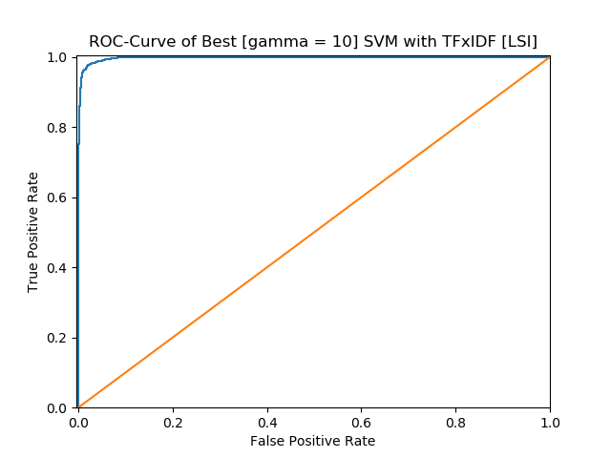

 | Precision | Recall | Accuracy
Computer technology | 0.9818 | 0.9679 | 0.9752
Recreational activity | 0.9690 | 0.9824 | 0.9752
Average | 0.9752 | 0.9754 | 0.9752

 | TP | FP | FN | TN
Computer technology | 1510 | 28 | 50 | 1562
Recreational activity | 1562 | 50 | 28 | 1510
We set computer technology as positive and recreational activity as negative to construct the confusion matrix as follow:
 | Ground Truth | Ground False
Predicted positive | 1510 | 28
Predicted negative | 50 | 1562

SVM with TFxIDF [NMF]
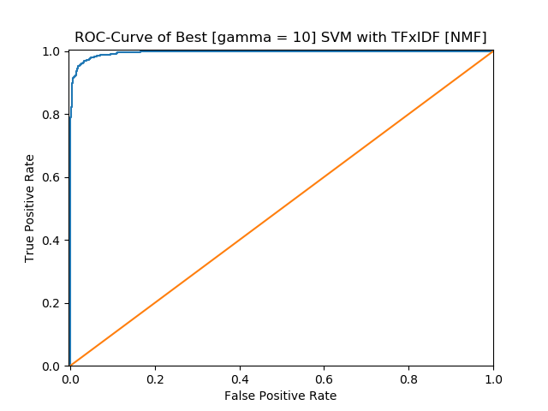

 | Precision | Recall | Accuracy
Computer technology | 0.9738 | 0.9538 | 0.9644
Recreational activity | 0.9556 | 0.9748 | 0.9644
Average | 0.9643 | 0.9647 | 0.9644

 | TP | FP | FN | TN
Computer technology | 1488 | 40 | 72 | 1550
Recreational activity | 1550 | 72 | 40 | 1488
We set computer technology as positive and recreational activity as negative to construct the confusion matrix as follow:
 | Ground Truth | Ground False
Predicted positive | 1488 | 40
Predicted negative | 72 | 1550

When min_df=5
[gamma = 0.001] 5-Fold Average Accuracy: 0.94695967
[gamma = 0.01] 5-Fold Average Accuracy: 0.96640173
[gamma = 0.1] 5-Fold Average Accuracy: 0.97020656
[gamma = 1.0] 5-Fold Average Accuracy: 0.97506535
[gamma = 10] 5-Fold Average Accuracy: 0.97612198
[gamma = 100] 5-Fold Average Accuracy: 0.97548840
[gamma = 1000] 5-Fold Average Accuracy: 0.95838086
Best Accuracy is 0.97612198 when gamma = 10

- SVM with TFxIDF [LSI]
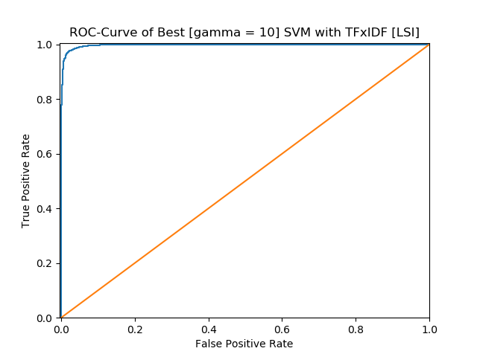

 | Precision | Recall | Accuracy
Computer technology | 0.9812 | 0.9679 | 0.9749
Recreational activity | 0.9690 | 0.9818 | 0.9749
Average | 0.9749 | 0.9751 | 0.9749

 | TP | FP | FN | TN
Computer technology | 1510 | 29 | 50 | 1561
Recreational activity | 1561 | 50 | 29 | 1510
We set computer technology as positive and recreational activity as negative to construct the confusion matrix as follow:
 | Ground Truth | Ground False
Predicted positive | 1510 | 29
Predicted negative | 50 | 1561

- SVM with TFxIDF [NMF]
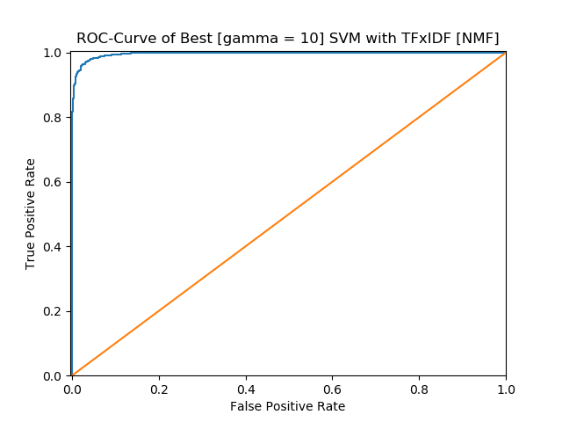

 | Precision | Recall | Accuracy
Computer technology | 0.9784 | 0.9564 | 0.9679
Recreational activity | 0.9582 | 0.9792 | 0.9679
Average | 0.9678 | 0.9683 | 0.9679

 | TP | FP | FN | TN
Computer technology | 1492 | 33 | 68 | 1557
Recreational activity | 1557 | 68 | 33 | 1492
We set computer technology as positive and recreational activity as negative to construct the confusion matrix as follow:
 | Ground Truth | Ground False
Predicted positive | 1492 | 33
Predicted negative | 68 | 1557

7. Naïve Bayes algorithm
Next, we use naïve Bayes algorithm for the same classification task.
When min_df=2
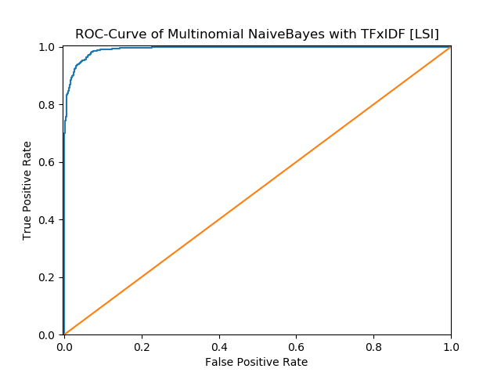

 | Precision | Recall | Accuracy
Computer technology | 0.9927 | 0.8718 | 0.9333
Recreational activity | 0.8876 | 0.9937 | 0.9333
Average | 0.9328 | 0.9402 | 0.9333

 | TP | FP | FN | TN
Computer technology | 1360 | 10 | 200 | 1580
Recreational activity | 1580 | 200 | 10 | 1360
We set computer technology as positive and recreational activity as negative to construct the confusion matrix as follow:
 | Ground Truth | Ground False
Predicted positive | 1360 | 10
Predicted negative | 200 | 1580

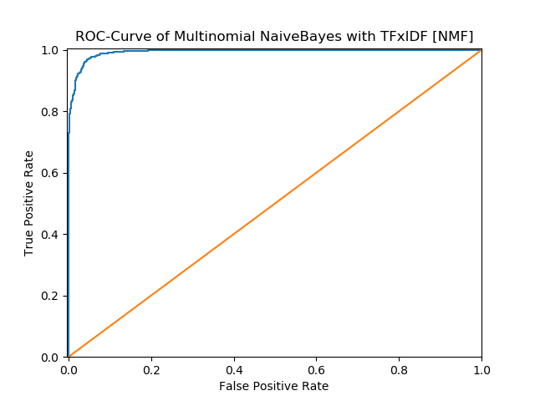

 | Precision | Recall | Accuracy
Computer technology | 0.9773 | 0.9397 | 0.9594
Recreational activity | 0.9430 | 0.9786 | 0.9594
Average | 0.9592 | 0.9602 | 0.9594

 | TP | FP | FN | TN
Computer technology | 1466 | 34 | 94 | 1556
Recreational activity | 1556 | 94 | 34 | 1466
We set computer technology as positive and recreational activity as negative to construct the confusion matrix as follow:
 | Ground Truth | Ground False
Predicted positive | 1466 | 34
Predicted negative | 94 | 1556

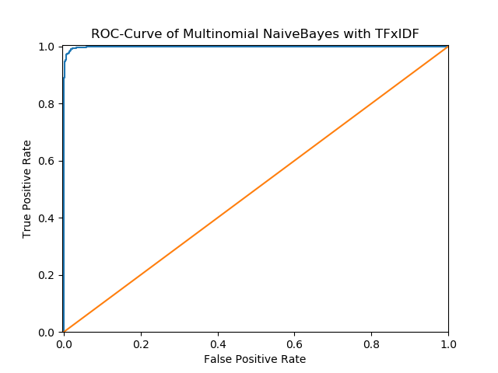

 | Precision | Recall | Accuracy
Computer technology | 0.9890 | 0.9814 | 0.9854
Recreational activity | 0.9819 | 0.9893 | 0.9854
Average | 0.9854 | 0.9855 | 0.9854

 | TP | FP | FN | TN
Computer technology | 1531 | 17 | 29 | 1573
Recreational activity | 1573 | 29 | 17 | 1531

We set computer technology as positive and recreational activity as negative to construct the confusion matrix as follow:
 | Ground Truth | Ground False
Predicted positive | 1531 | 17
Predicted negative | 29 | 1573

When min_df=5
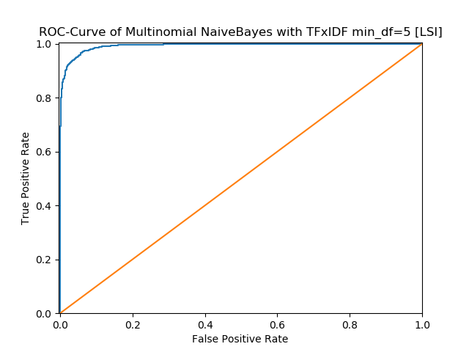

 | Precision | Recall | Accuracy
Computer technology | 0.9967 | 0.7686 | 0.8841
Recreational activity | 0.8146 | 0.9975 | 0.8841
Average | 0.8830 | 0.9056 | 0.8841

 | TP | FP | FN | TN
Computer technology | 1199 | 4 | 361 | 1586
Recreational activity | 1586 | 361 | 4 | 1199
We set computer technology as positive and recreational activity as negative to construct the confusion matrix as follow:
 | Ground Truth | Ground False
Predicted positive | 1199 | 4
Predicted negative | 361 | 1586

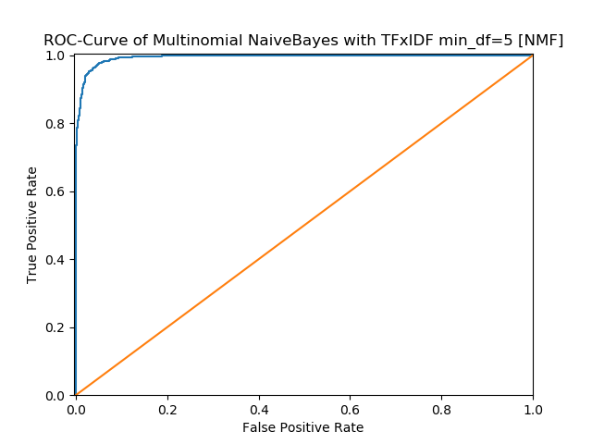

 | Precision | Recall | Accuracy
Computer technology | 0.9811 | 0.9333 | 0.9581
Recreational activity | 0.9376 | 0.9824 | 0.9581
Average | 0.9579 | 0.9594 | 0.9581

 | TP | FP | FN | TN
Computer technology | 1456 | 28 | 104 | 1562
Recreational activity | 1562 | 104 | 28 | 1456
We set computer technology as positive and recreational activity as negative to construct the confusion matrix as follow:
 | Ground Truth | Ground False
Predicted positive | 1456 | 28
Predicted negative | 104 | 1562

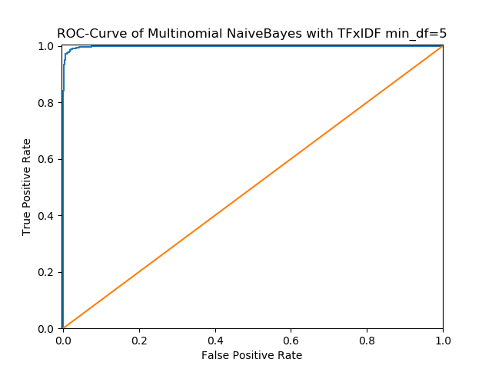

 | Precision | Recall | Accuracy
Computer technology | 0.9771 | 0.9840 | 0.9806
Recreational activity | 0.9842 | 0.9774 | 0.9806
Average | 0.9807 | 0.9806 | 0.9806

 | TP | FP | FN | TN
Computer technology | 1535 | 36 | 25 | 1554
Recreational activity | 1554 | 25 | 36 | 1535
We set computer technology as positive and recreational activity as negative to construct the confusion matrix as follow:
 | Ground Truth | Ground False
Predicted positive | 1535 | 36
Predicted negative | 25 | 1554

8. logistic regression classifier
When min_df=2
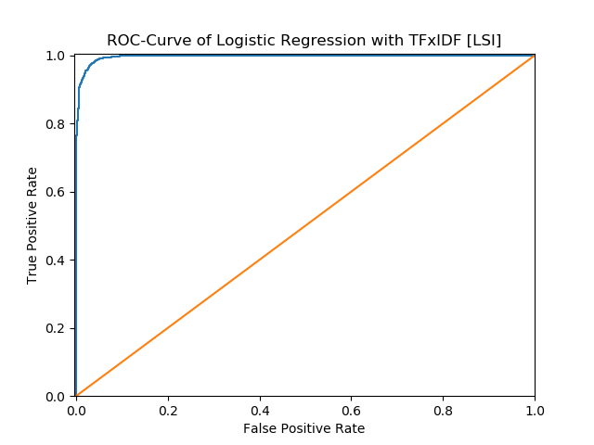

 | Precision | Recall | Accuracy
Computer technology | 0.9804 | 0.9603 | 0.9708
Recreational activity | 0.9618 | 0.9811 | 0.9708
Average | 0.9707 | 0.9711 | 0.9708

 | TP | FP | FN | TN
Computer technology | 1498 | 30 | 62 | 1560
Recreational activity | 1560 | 62 | 30 | 1498

We set computer technology as positive and recreational activity as negative to construct the confusion matrix as follow:
 | Ground Truth | Ground False
Predicted positive | 1498 | 30
Predicted negative | 62 | 1560

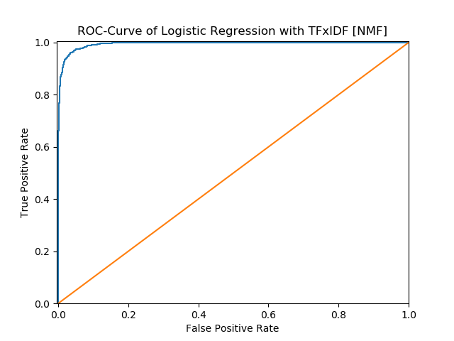

 | Precision | Recall | Accuracy
Computer technology | 0.9657 | 0.9551 | 0.9610
Recreational activity | 0.9564 | 0.9667 | 0.9610
Average | 0.9609 | 0.9610 | 0.9610

 | TP | FP | FN | TN
Computer technology | 1490 | 53 | 70 | 1573
Recreational activity | 1537 | 70 | 53 | 1490

We set computer technology as positive and recreational activity as negative to construct the confusion matrix as follow:
 | Ground Truth | Ground False
Predicted positive | 1490 | 53
Predicted negative | 70 | 1537

When min_df=5
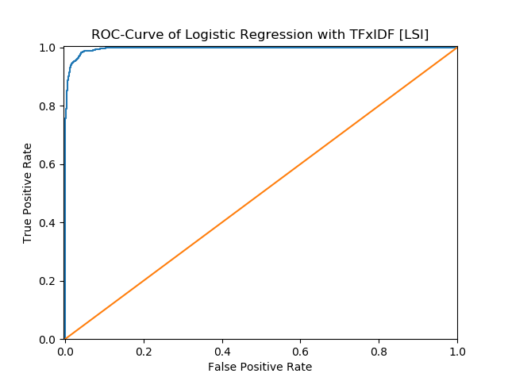

 | Precision | Recall | Accuracy
Computer technology | 0.9784 | 0.9596 | 0.9695
Recreational activity | 0.9611 | 0.9792 | 0.9695
Average | 0.9694 | 0.9698 | 0.9695

 | TP | FP | FN | TN
Computer technology | 1497 | 33 | 63 | 1557
Recreational activity | 1557 | 63 | 33 | 1497

We set computer technology as positive and recreational activity as negative to construct the confusion matrix as follow:
 | Ground Truth | Ground False
Predicted positive | 1497 | 33
Predicted negative | 63 | 1557

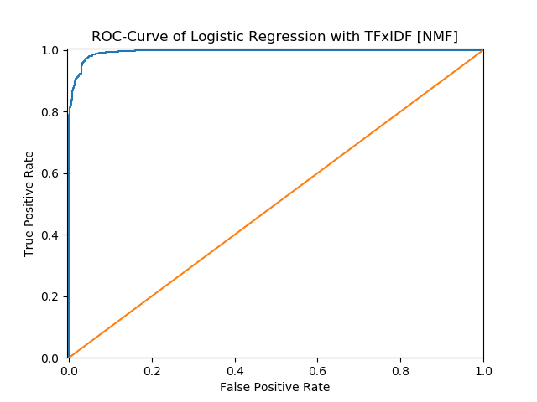

 | Precision | Recall | Accuracy
Computer technology | 0.9683 | 0.9603 | 0.9648
Recreational activity | 0.9613 | 0.9692 | 0.9648
Average | 0.9647 | 0.9648 | 0.9648

 | TP | FP | FN | TN
Computer technology | 1498 | 49 | 62 | 1541
Recreational activity | 1541 | 62 | 49 | 1498

We set computer technology as positive and recreational activity as negative to construct the confusion matrix as follow:
 | Ground Truth | Ground False
Predicted positive | 1498 | 49
Predicted negative | 62 | 1541

9. Optimize model
Now, by adding a regularization term to the optimization objective. Try both L1 and L2 norm regularizations and sweep through different regularization coefficients, ranging from very small ones to large ones. How does the regularization parameter affect the test error? How are the coefficients of the fitted hyperplane affected? Why might one be interested in each type of
regularization?
整体趋势 参数越大 准确率越高 min=5 更好
C from the 0.001 to 10, and we choice the best score to output
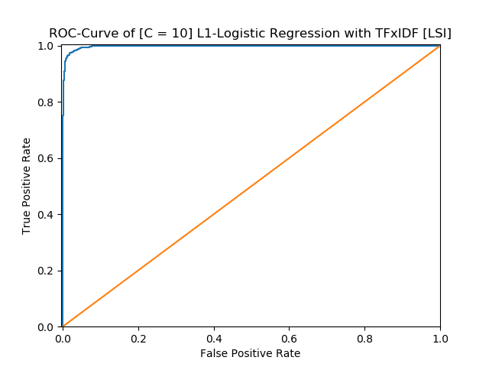

 | Precision | Recall | Accuracy
Computer technology | 0.9817 | 0.9654 | 0.9740
Recreational activity | 0.9666 | 0.9824 | 0.9740
Average | 0.9739 | 0.9742 | 0.9740

 | TP | FP | FN | TN
Computer technology | 1506 | 28 | 54 | 1562
Recreational activity | 1562 | 54 | 28 | 1506

We set computer technology as positive and recreational activity as negative to construct the confusion matrix as follow:
 | Ground Truth | Ground False
Predicted positive | 1562 | 28
Predicted negative | 54 | 1562
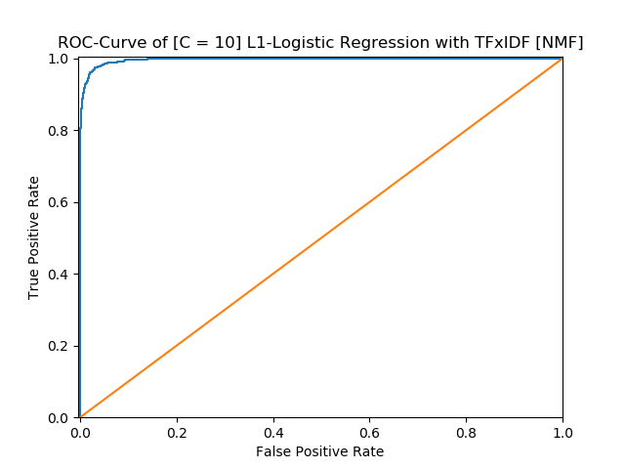

 | Precision | Recall | Accuracy
Computer technology | 0.9790 | 0.9551 | 0.9676
Recreational activity | 0.9570 | 0.9799 | 0.9676
Average | 0.9675 | 0.9680 | 0.9676

 | TP | FP | FN | TN
Computer technology | 1490 | 32 | 70 | 1558
Recreational activity | 1558 | 70 | 32 | 1490

We set computer technology as positive and recreational activity as negative to construct the confusion matrix as follow:
 | Ground Truth | Ground False
Predicted positive | 1490 | 32
Predicted negative | 70 | 1558
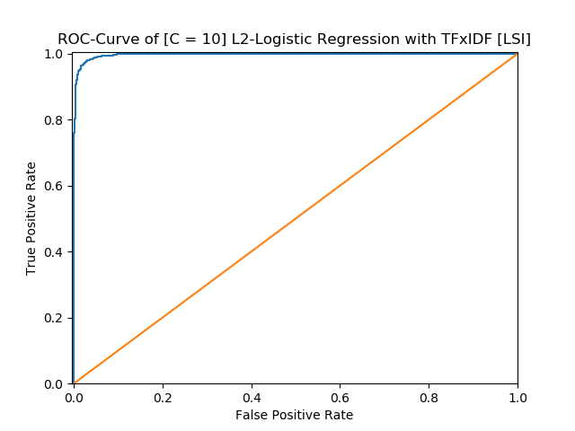

 | Precision | Recall | Accuracy
Computer technology | 0.9817 | 0.9635 | 0.9730
Recreational activity | 0.9648 | 0.9824 | 0.9730
Average | 0.9729 | 0.9733 | 0.9730

 | TP | FP | FN | TN
Computer technology | 1503 | 28 | 57 | 1562
Recreational activity | 1562 | 57 | 28 | 1503

We set computer technology as positive and recreational activity as negative to construct the confusion matrix as follow:
 | Ground Truth | Ground False
Predicted positive | 1503 | 28
Predicted negative | 57 | 1562
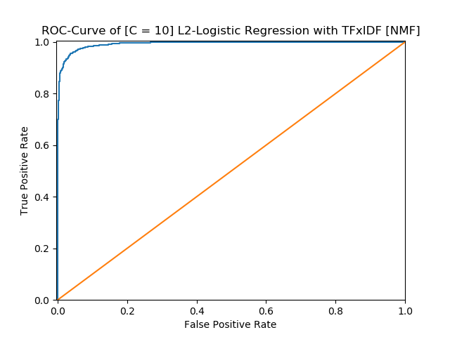

 | Precision | Recall | Accuracy
Computer technology | 0.9659 | 0.9455 | 0.9565
Recreational activity | 0.9476 | 0.9673 | 0.9565
Average | 0.9564 | 0.9568 | 0.9565

 | TP | FP | FN | TN
Computer technology | 1475 | 52 | 85 | 1538
Recreational activity | 1538 | 85 | 52 | 1475

We set computer technology as positive and recreational activity as negative to construct the confusion matrix as follow:
 | Ground Truth | Ground False
Predicted positive | 1475 | 52
Predicted negative | 85 | 1538

When min_df=5
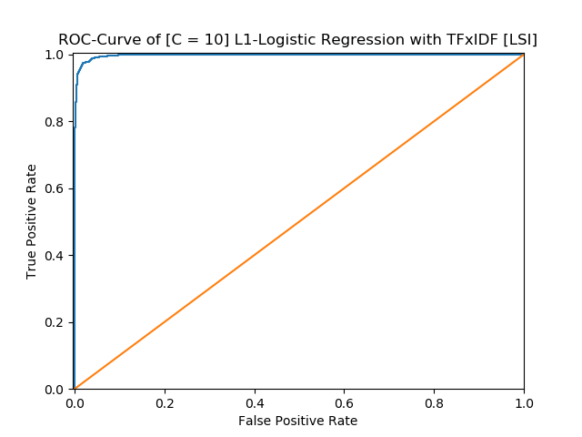

 | Precision | Recall | Accuracy
Computer technology | 0.9798 | 0.9654 | 0.9730
Recreational activity | 0.9665 | 0.9805 | 0.9730
Average | 0.9729 | 0.9732 | 0.9730

 | TP | FP | FN | TN
Computer technology | 1506 | 31 | 54 | 1559
Recreational activity | 1559 | 54 | 31 | 1506

We set computer technology as positive and recreational activity as negative to construct the confusion matrix as follow:
 | Ground Truth | Ground False
Predicted positive | 1506 | 31
Predicted negative | 54 | 1559
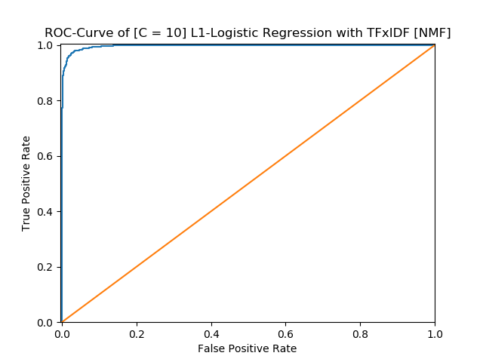

 | Precision | Recall | Accuracy
Computer technology | 0.9810 | 0.9603 | 0.9711
Recreational activity | 0.9618 | 0.9818 | 0.9711
Average | 0.9710 | 0.9714 | 0.9711

 | TP | FP | FN | TN
Computer technology | 1498 | 29 | 62 | 1561
Recreational activity | 1561 | 62 | 29 | 1498

We set computer technology as positive and recreational activity as negative to construct the confusion matrix as follow:
 | Ground Truth | Ground False
Predicted positive | 1498 | 29
Predicted negative | 62 | 1561
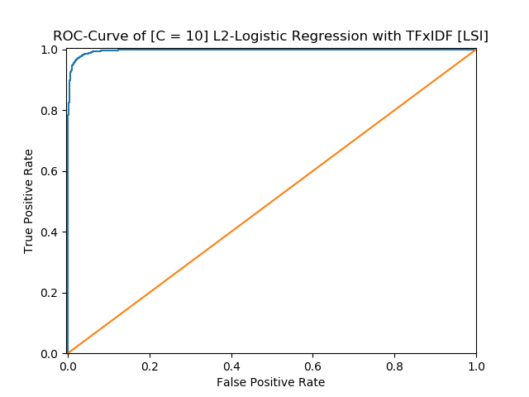

 | Precision | Recall | Accuracy
Computer technology | 0.9811 | 0.9647 | 0.9733
Recreational activity | 0.9660 | 0.9818 | 0.9733
Average | 0.9733 | 0.9735 | 0.9733

 | TP | FP | FN | TN
Computer technology | 1505 | 29 | 55 | 1561
Recreational activity | 1561 | 55 | 29 | 1505

We set computer technology as positive and recreational activity as negative to construct the confusion matrix as follow:
 | Ground Truth | Ground False
Predicted positive | 1505 | 29
Predicted negative | 55 | 1561
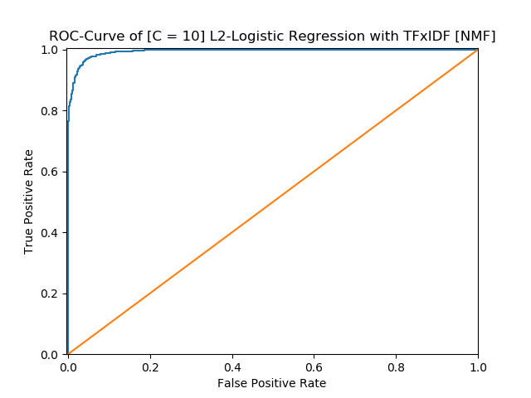

 | Precision | Recall | Accuracy
Computer technology | 0.9711 | 0.9487 | 0.9606
Recreational activity | 0.9508 | 0.9732 | 0.9606
Average | 0.9605 | 0.9610 | 0.9606

 | TP | FP | FN | TN
Computer technology | 1480 | 44 | 80 | 1546
Recreational activity | 1546 | 80 | 44 | 1480

We set computer technology as positive and recreational activity as negative to construct the confusion matrix as follow:
 | Ground Truth | Ground False
Predicted positive | 1480 | 44
Predicted negative | 80 | 1546

10. Multi- Class
In this part, we aim to perform Naïve Bayes classification and multiclass SVM classification (with both One VS One and One VS the rest methods described above) and report the confusion matrix and calculate the accuracy, recall and precision of your classifiers

Multinomial NaiveBayes with TFIDF threshold is 2 [LSI]

 | Precision | Recall | Accuracy
comp.sys.ibm.pc.hardware | 0.7717 | 0.6811 | 0.8696
comp.sys.mac.hardware | 0.8177 | 0.7688 | 0.9010
misc.forsale | 0.7131 | 0.8667 | 0.8799
soc.religion.christian | 0.9765 | 0.9397 | 0.9789
Average | 0.8141 | 0.8197 | 0.9073

 | TP | FP | FN | TN
comp.sys.ibm.pc.hardware | 267 | 79 | 125 | 1094
comp.sys.mac.hardware | 296 | 66 | 89 | 1114
misc.forsale | 338 | 136 | 52 | 1039
soc.religion.christian | 374 | 9 | 24 | 1158

We set comp.sys.ibm.pc.hardware as positive and others as negative to construct the confusion matrix as follow:
 | Ground Truth | Ground False
Predicted positive | 267 | 79
Predicted negative | 125 | 1094

Multinomial NaiveBayes with TFIDF threshold is 2 [NMF]

 | Precision | Recall | Accuracy
comp.sys.ibm.pc.hardware | 0.8054 | 0.7602 | 0.8939
comp.sys.mac.hardware | 0.8226 | 0.7948 | 0.9073
misc.forsale | 0.8000 | 0.8615 | 0.9118
soc.religion.christian | 0.9752 | 0.9874 | 0.9904
Average | 0.8510 | 0.8508 | 0.9259

 | TP | FP | FN | TN
comp.sys.ibm.pc.hardware | 298 | 72 | 94 | 1101
comp.sys.mac.hardware | 306 | 66 | 79 | 1114
misc.forsale | 336 | 84 | 54 | 1091
soc.religion.christian | 393 | 10 | 5 | 1157

We set comp.sys.ibm.pc.hardware as positive and others as negative to construct the confusion matrix as follow:
 | Ground Truth | Ground False
Predicted positive | 336 | 84
Predicted negative | 54 | 1091

Multinomial NaiveBayes with TFIDF threshold is 5 [LSI]
 | Precision | Recall | Accuracy
comp.sys.ibm.pc.hardware | 0.7237 | 0.8087 | 0.8748
comp.sys.mac.hardware | 0.9022 | 0.6468 | 0.8958
misc.forsale | 0.8739 | 0.7821 | 0.9176
soc.religion.christian | 0.7928 | 1.0000 | 0.9335
Average | 0.8094 | 0.8232 | 0.9054

 | TP | FP | FN | TN
comp.sys.ibm.pc.hardware | 317 | 121 | 75 | 1052
comp.sys.mac.hardware | 249 | 27 | 136 | 1153
misc.forsale | 305 | 44 | 85 | 1131
soc.religion.christian | 398 | 104 | 0 | 1063

We set comp.sys.ibm.pc.hardware as positive and others as negative to construct the confusion matrix as follow:
 | Ground Truth | Ground False
Predicted positive | 317 | 121
Predicted negative | 75 | 1052

Multinomial NaiveBayes with TFIDF threshold is 5 [NMF]
 | Precision | Recall | Accuracy
comp.sys.ibm.pc.hardware | 0.7558 | 0.7500 | 0.8767
comp.sys.mac.hardware | 0.7836 | 0.7714 | 0.8914
misc.forsale | 0.8321 | 0.8513 | 0.9201
soc.religion.christian | 0.9824 | 0.9824 | 0.9911
Average | 0.8388 | 0.8385 | 0.9198

 | TP | FP | FN | TN
comp.sys.ibm.pc.hardware | 294 | 95 | 98 | 1078
comp.sys.mac.hardware | 297 | 82 | 88 | 1198
misc.forsale | 332 | 67 | 58 | 1108
soc.religion.christian | 391 | 7 | 7 | 1160

We set comp.sys.ibm.pc.hardware as positive and others as negative to construct the confusion matrix as follow:
 | Ground Truth | Ground False
Predicted positive | 294 | 95
Predicted negative | 98 | 1078

SVM
Multy SVM ovo with TFIDF threshold is 5 [LSI]
 | Precision | Recall | Accuracy
comp.sys.ibm.pc.hardware | 0.7815 | 0.8393 | 0.8748
comp.sys.mac.hardware | 0.8497 | 0.8078 | 0.9010
misc.forsale | 0.9415 | 0.7846 | 0.9342
soc.religion.christian | 0.8764 | 0.9975 | 0.9636
Average | 0.8573 | 0.8623 | 0.9291

 | TP | FP | FN | TN
comp.sys.ibm.pc.hardware | 329 | 92 | 63 | 1081
comp.sys.mac.hardware | 311 | 55 | 74 | 1125
misc.forsale | 306 | 19 | 84 | 1156
soc.religion.christian | 397 | 56 | 1 | 1111

We set comp.sys.ibm.pc.hardware as positive and others as negative to construct the confusion matrix as follow:
 | Ground Truth | Ground False
Predicted positive | 329 | 92
Predicted negative | 63 | 1081

Multy SVM ovo with TFIDF threshold is 5 [NMF]
 | Precision | Recall | Accuracy
comp.sys.ibm.pc.hardware | 0.5883 | 0.9005 | 0.8173
comp.sys.mac.hardware | 0.8517 | 0.6416 | 0.8843
misc.forsale | 0.9649 | 0.7051 | 0.9201
soc.religion.christian | 0.9769 | 0.9573 | 0.9834
Average | 0.8011 | 0.8455 | 0.9013

 | TP | FP | FN | TN
comp.sys.ibm.pc.hardware | 353 | 247 | 39 | 926
comp.sys.mac.hardware | 247 | 43 | 138 | 1137
misc.forsale | 275 | 10 | 115 | 1165
soc.religion.christian | 381 | 9 | 17 | 1158

We set comp.sys.ibm.pc.hardware as positive and others as negative to construct the confusion matrix as follow:
 | Ground Truth | Ground False
Predicted positive | 353 | 247
Predicted negative | 39 | 926

Multy SVM ovr with TFIDF threshold is 5 [LSI]
 | Precision | Recall | Accuracy
comp.sys.ibm.pc.hardware | 0.7815 | 0.8393 | 0.9010
comp.sys.mac.hardware | 0.8497 | 0.8078 | 0.9176
misc.forsale | 0.9415 | 0.7846 | 0.9342
soc.religion.christian | 0.8764 | 0.9975 | 0.9636
Average | 0.8573 | 0.8623 | 0.9291

 | TP | FP | FN | TN
comp.sys.ibm.pc.hardware | 329 | 92 | 63 | 1081
comp.sys.mac.hardware | 311 | 55 | 74 | 1125
misc.forsale | 306 | 19 | 84 | 1156
soc.religion.christian | 397 | 56 | 1 | 1111

We set comp.sys.ibm.pc.hardware as positive and others as negative to construct the confusion matrix as follow:
 | Ground Truth | Ground False
Predicted positive | 329 | 92
Predicted negative | 63 | 1081

Multy SVM ovr with TFIDF threshold is 5 [NMF]
 | Precision | Recall | Accuracy
comp.sys.ibm.pc.hardware | 0.5883 | 0.9005 | 0.8173
comp.sys.mac.hardware | 0.8517 | 0.6416 | 0.8843
misc.forsale | 0.9649 | 0.7051 | 0.9201
soc.religion.christian | 0.9769 | 0.9573 | 0.9834
Average | 0.8011 | 0.8455 | 0.9013

 | TP | FP | FN | TN
comp.sys.ibm.pc.hardware | 353 | 247 | 39 | 926
comp.sys.mac.hardware | 247 | 43 | 138 | 1137
misc.forsale | 275 | 10 | 115 | 1165
soc.religion.christian | 381 | 9 | 17 | 1158

We set comp.sys.ibm.pc.hardware as positive and others as negative to construct the confusion matrix as follow:
 | Ground Truth | Ground False
Predicted positive | 353 | 247
Predicted negative | 39 | 926

Multy SVM ovo with TFIDF threshold is 2 [LSI]
 | Precision | Recall | Accuracy
comp.sys.ibm.pc.hardware | 0.8686 | 0.6071 | 0.8786
comp.sys.mac.hardware | 0.7445 | 0.8857 | 0.8971
misc.forsale | 0.7773 | 0.8949 | 0.9099
soc.religion.christian | 0.9870 | 0.9523 | 0.9847
Average | 0.8350 | 0.8444 | 0.9176

 | TP | FP | FN | TN
comp.sys.ibm.pc.hardware | 238 | 36 | 154 | 1137
comp.sys.mac.hardware | 341 | 117 | 44 | 1063
misc.forsale | 349 | 100 | 41 | 1075
soc.religion.christian | 379 | 5 | 19 | 1162

We set comp.sys.ibm.pc.hardware as positive and others as negative to construct the confusion matrix as follow:
 | Ground Truth | Ground False
Predicted positive | 238 | 36
Predicted negative | 154 | 1137

Multy SVM ovo with TFIDF threshold is 2 [NMF]
 | Precision | Recall | Accuracy
comp.sys.ibm.pc.hardware | 0.6313 | 0.8954 | 0.8428
comp.sys.mac.hardware | 0.8338 | 0.7039 | 0.8927
misc.forsale | 0.9630 | 0.7333 | 0.9265
soc.religion.christian | 0.9897 | 0.9623 | 0.9879
Average | 0.8237 | 0.8544 | 0.9125

 | TP | FP | FN | TN
comp.sys.ibm.pc.hardware | 351 | 205 | 41 | 968
comp.sys.mac.hardware | 271 | 54 | 114 | 1126
misc.forsale | 286 | 11 | 104 | 1164
soc.religion.christian | 383 | 4 | 15 | 1163

We set comp.sys.ibm.pc.hardware as positive and others as negative to construct the confusion matrix as follow:
 | Ground Truth | Ground False
Predicted positive | 351 | 205
Predicted negative | 41 | 968

Multy SVM ovr with TFIDF threshold is 2 [LSI]
 | Precision | Recall | Accuracy
comp.sys.ibm.pc.hardware | 0.8686 | 0.6071 | 0.8786
comp.sys.mac.hardware | 0.7445 | 0.8857 | 0.8971
misc.forsale | 0.7773 | 0.8949 | 0.9099
soc.religion.christian | 0.9870 | 0.9523 | 0.9847
Average | 0.8350 | 0.8444 | 0.9176

 | TP | FP | FN | TN
comp.sys.ibm.pc.hardware | 238 | 36 | 154 | 1137
comp.sys.mac.hardware | 341 | 117 | 44 | 1063
misc.forsale | 349 | 100 | 41 | 1075
soc.religion.christian | 379 | 5 | 19 | 1162

We set comp.sys.ibm.pc.hardware as positive and others as negative to construct the confusion matrix as follow:
 | Ground Truth | Ground False
Predicted positive | 238 | 36
Predicted negative | 154 | 1137

Multy SVM ovr with TFIDF threshold is 2 [NMF]
 | Precision | Recall | Accuracy
comp.sys.ibm.pc.hardware | 0.6313 | 0.8954 | 0.8428
comp.sys.mac.hardware | 0.8338 | 0.7039 | 0.8927
misc.forsale | 0.9630 | 0.7333 | 0.9265
soc.religion.christian | 0.9897 | 0.9623 | 0.9879
Average | 0.8237 | 0.8544 | 0.9125

 | TP | FP | FN | TN
comp.sys.ibm.pc.hardware | 351 | 205 | 41 | 968
comp.sys.mac.hardware | 271 | 54 | 114 | 1126
misc.forsale | 286 | 11 | 104 | 1164
soc.religion.christian | 383 | 4 | 15 | 1163

We set comp.sys.ibm.pc.hardware as positive and others as negative to construct the confusion matrix as follow:
 | Ground Truth | Ground False
Predicted positive | 351 | 205
Predicted negative | 41 | 968

